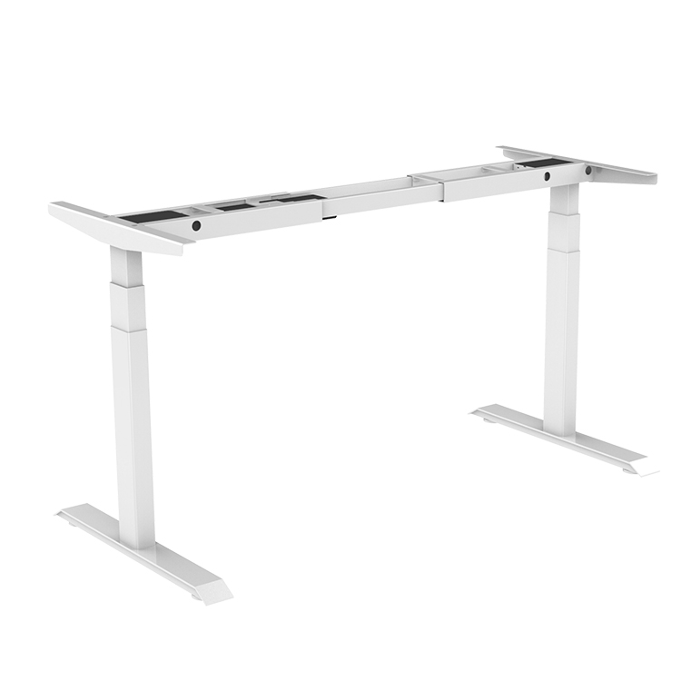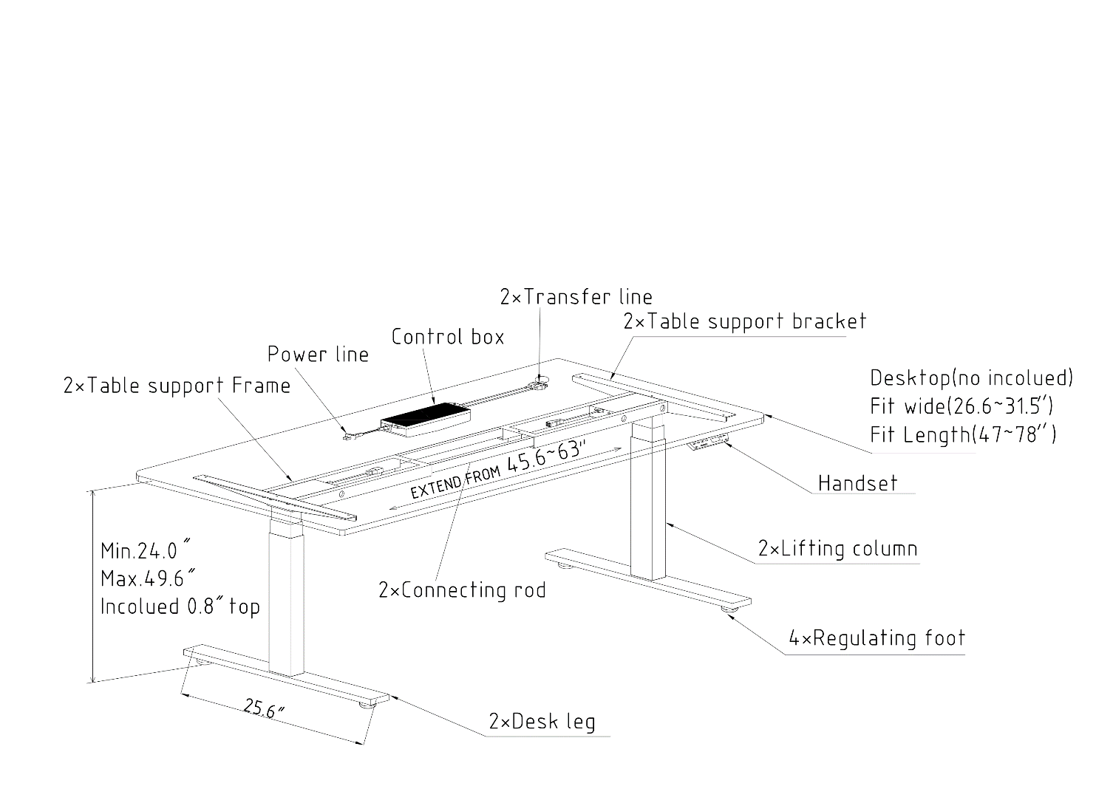
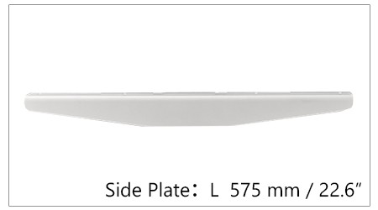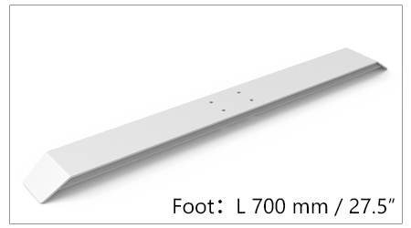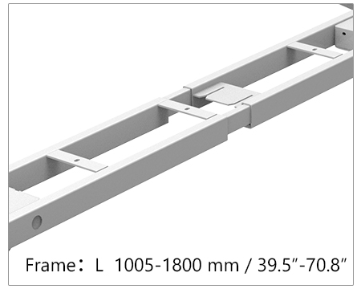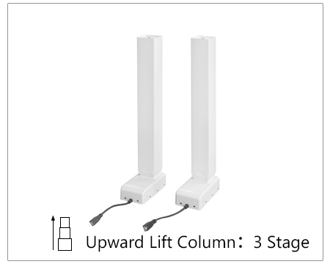

product NO. |  | Column stages | 3 stages
Height Adjustment | 600-1250mm | Column shape&size | rectangular 80*50mm
Max.speed | 38mm/s | Column direction | Inversion
Input voltage | 110-230VAC | Desk foot style | beveled
Load capacity | 1400N | Motor Numbers | Dual motors
Length | 1100-1800mm | working noise | less than 50db
Color | White;Black;Grey | Anti-collision system | Y
Duty cycle | 10%;Max.2min.off | warranty | 5years

Certificates | UL, CE,ROHS ,CTICK, CTUVUS, SAA, KC,BEFMA ,LVD

Customizable item | LOGO,Stroke,Column shape,Desk foot and Side plate shape

